**Unit 1 Basic Database Concepts**

***Learners should be able to:***

**10.1.1** identify applications suitable for a database

**10.1.2** define the terms: database, character, field, record, file, data

type and key field

**10.1.3** identify possible data types as being numeric, character, date

and logical

**10.1.4** access a database system

**10.1.5** identify component parts of a record structure

**10.1.6** create a database file from a given structure

**10.1.7** enter data

**10.1.8** edit data

**10.1.9** add new records

**10.1.10** delete individual records

**10.1.11** modify database structure

**10.1.12** save database

**10.1.13** recall existing database

**10.1.14** browse the database

**10.1.15** query the database on a single field

**10.1.16** organise (sort and/or index) the database on a single field

3

**10.1.17** output data to screen and printer

**10.1.18** exit the database through use of proper procedures.

**10.1.1** identify applications suitable for a database

A database is a collection of information that has been organised so that the information is easy to access and display in different ways.

At the most basic level, a database is simply an organized collection of data. A database management system (DBMS) such as Microsoft Access, [Oracle](http://databases.about.com/cs/oracle/g/Oracle.htm) or [SQL Server](http://databases.about.com/od/sqlserver/tp/Top-Five-New-Features-In-Sql-Server-2011.htm) provides you with the software tools you need to organize that data in a flexible manner. It includes facilities to add, modify or delete data from the database, ask questions (or queries) about the data stored in the database and produce reports summarizing selected contents.

Databases are used everywhere: at work, in the home, in schools, and leisure facilities. Examples of a database would be a telephone directory, a mailing catalogue, or even a CD music library,or Itunes library.

Within Microsoft Access, a database simply refers to a collection of different data sets known as **Tables** which are potentially related and therefore joined together increasing data flexibility.

The process of relating and joining tables together is what makes **Access a Relational Database Management System (RDBMS)** and on the whole provides more flexible reporting and functionality within this application.

<http://www.youtube.com/watch?feature=player_embedded&v=eXiCza050ug>

What is a Database.

A database is a program that lets you store, organise and manipulate data.

In the past data was stored in paper files such as ledgers or index cards.

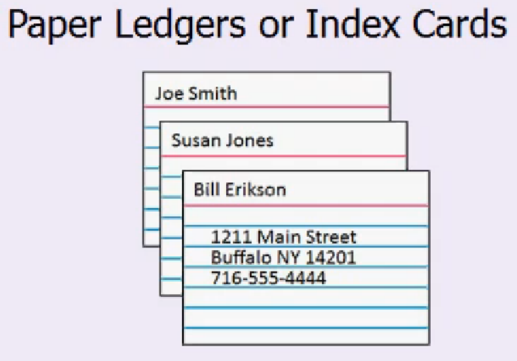

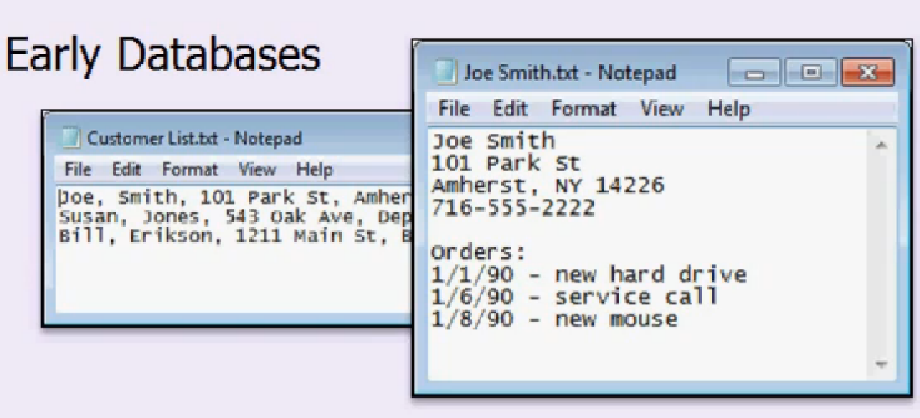

Early databases were basically lists of data which made storing and searching the data easier, but did not have the ability to identify relationships between different types of data.

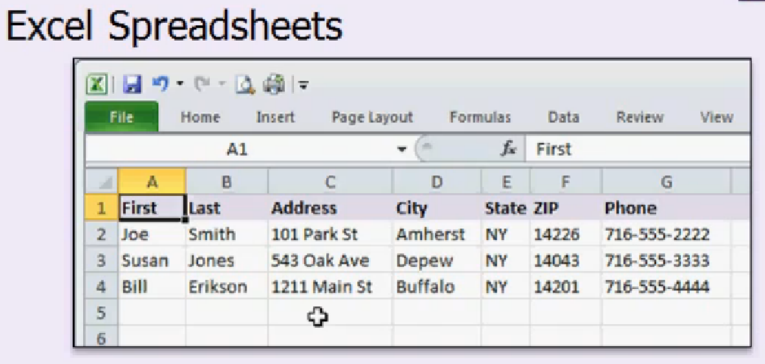

Great for small amounts of data. Not relational.

Difficult for novice users.

Access can build a nice user friendly interface.

Easy to secure the access database so users only access the data you want them to access.

Database terminology.

An access database consists of the data and the tools to work with this data.

|  |  |
| --- | --- |
| Tables | Store data. |
| Queries | Organise the data. |
| Forms | Display data on the screen. |
| Reports | Print out the data. |
| *Macros* | *Automate repetitive tasks* |
| *Modules* | *Programming full access to Visual Basic programming language.* |

Tables in access are like spreadsheets in excel. However there is much more control of the types of data that can be entered.

The lastName field is highlighted in red in the figure below. You can specify rules in the table so that fields will only accept specific data types, eg. Number, currency, text or date.

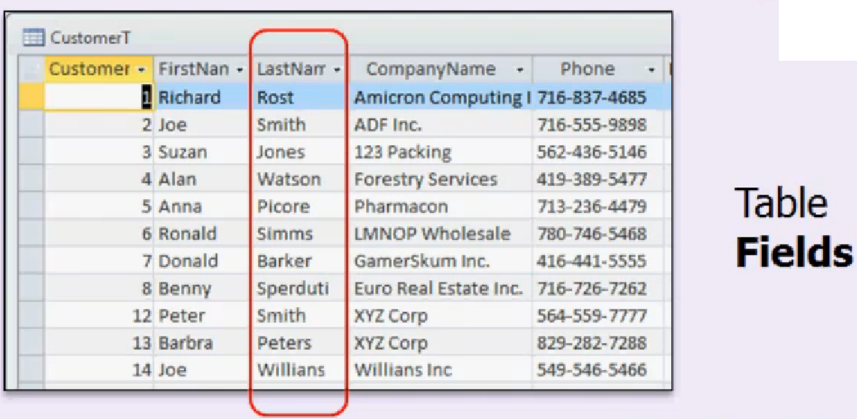

A **record** can be considered as a row in the column. The figure below highlights the record for Alan Watson.

* **primary keys**

The primary key is a field (column ) that is used to uniquely identify each row. An example might be Customer ID, or LastName. This must be a unique value.

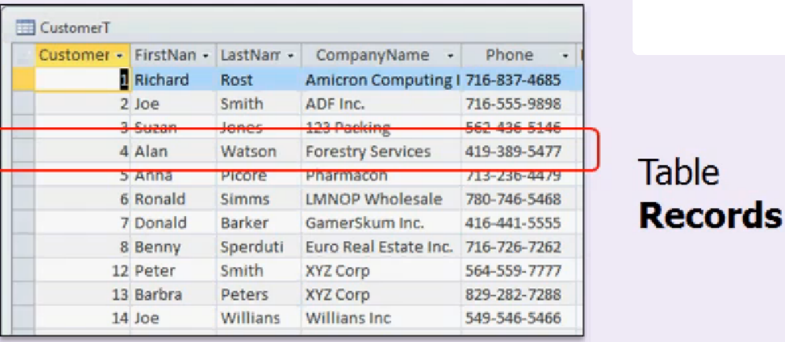

Queries.

A database may contain thousands of different pieces of data. A query is used to sort the data or apply criteria to only display certain data.

Queries can be used to add, delete and modify records.

Queries can be saved and reused so there is no need to redesign them.

Forms

Forms allow you to build a nice user friendly interface(UI). You can display data from different tables, secure the form so that the user can only modify certain data, display calculations on the form, display drop down lists so users can select from a list of data.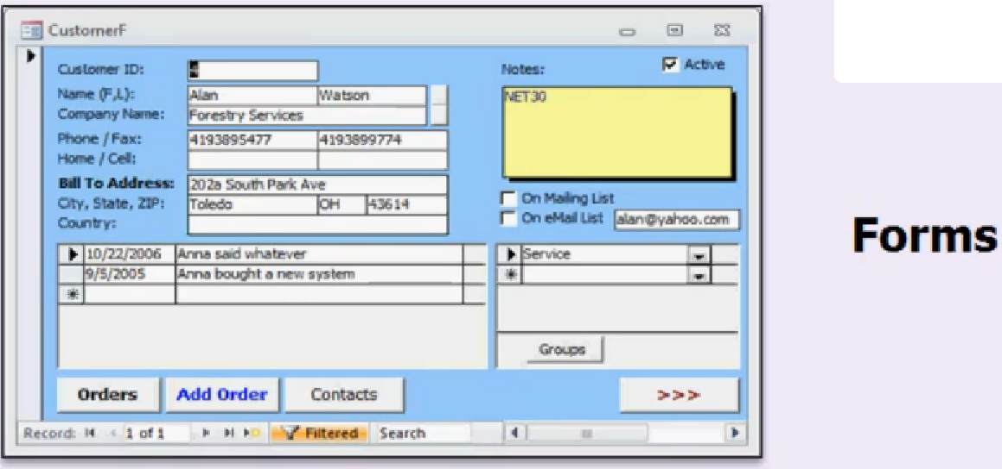

Reports:

Used to produce data for people who do not have access to the database. They can be used to produce an invoice, a printout or email of the data.

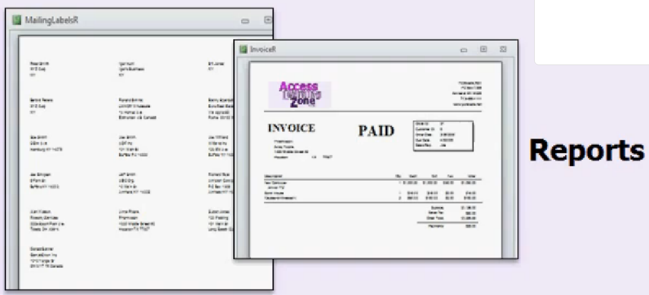

<http://www.youtube.com/watch?v=pHiOXZEbK-4>

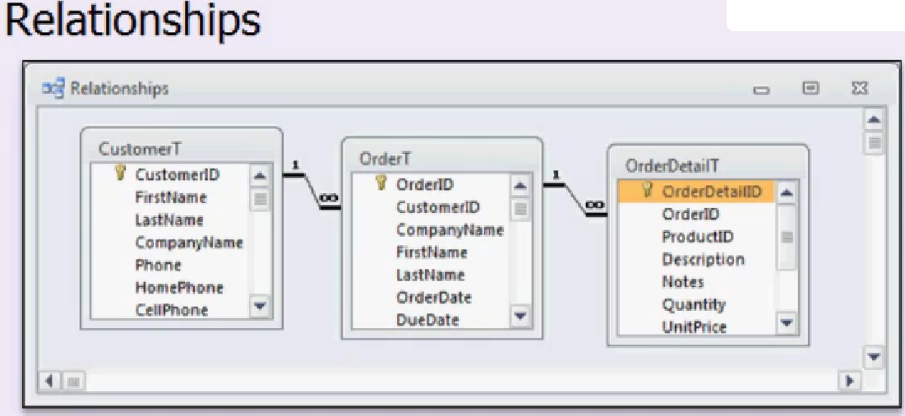

The process of relating and joining tables together is what makes Access a Relational Database Management System (RDBMS) and on the whole provides more flexible reporting and functionality within this application.

Creating a database in Microsoft access.

1. Open access 2010.
2. Create a new database called “accessdatatabase1.accdb”.
3. Save this to a folder called “Access 2010 databases”.
4. **Select the “Create” button to save the database.**

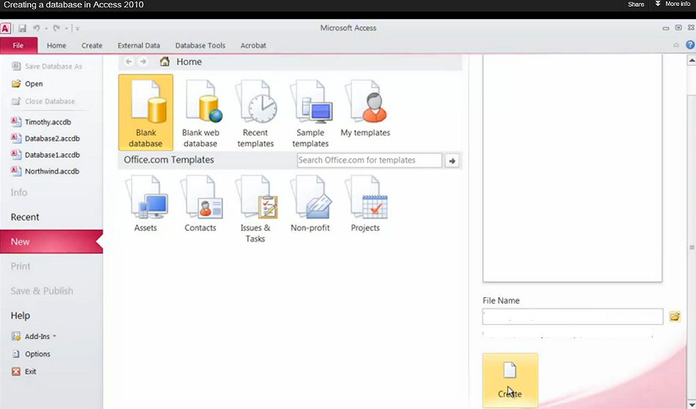

NB: Your database is not created unless you select the create button.

**Creating objects in Access.**

Creating a Table and adding fields.

1. Change the name of the default table to “Customer” clicking the “Save” icon.(Note: your table file is saved in the same folder as the database.
2. Rename the table “Customer” to “Customers”. Note: You must save and close the object before you can rename the object.
3. Add 3 new text fields called “Company Name”, “First Name”, “Last Name”.

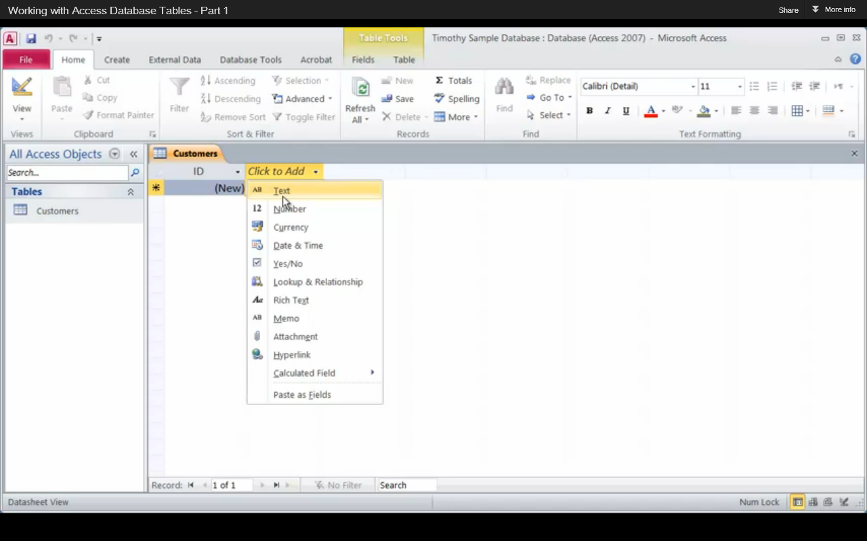

Working in Design View.

1. From the View menu select “Design View”.

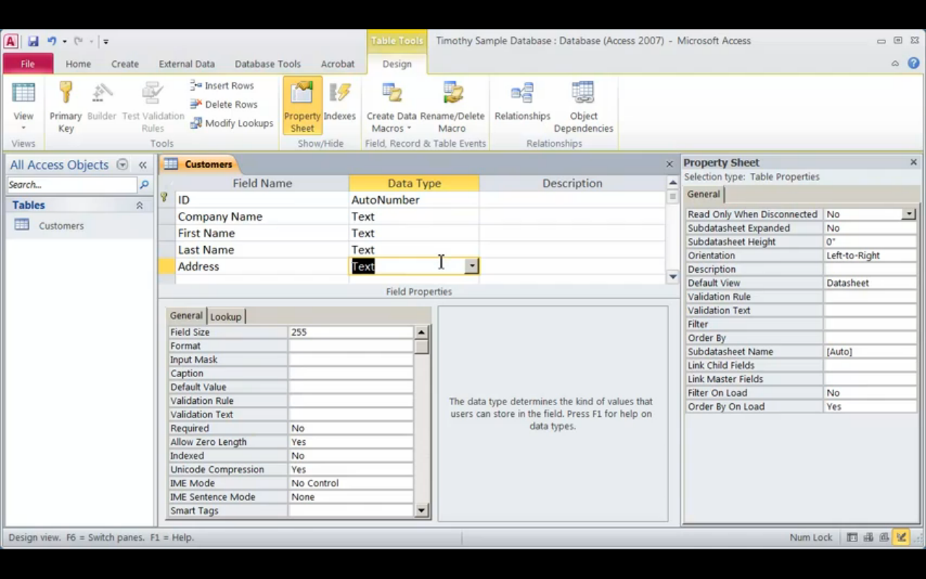

1. In design view add the following fields with Data Type “Text”

“Address”, “City”, “Country”, “Phone Number”, “Phone Number 2”.

1. Create the field “Comment” with Data Type “Memo”.
2. Highlight the “Phone Number” field and reposition it below the field “Address”.
3. Delete the field “Phone Number 2”.
4. In the design view change the field size of “First Name”, “Last Name” and “Country” to 25.
5. In the design view change the field size of “Address” to 55.
6. Return to Database view and enter in the following records.

|  |  |  |  |  |  |  |  |  |
| --- | --- | --- | --- | --- | --- | --- | --- | --- |
| ID | Company | First Name | Last Name | Address | Phone Number | City | Country | Comment |
| 1 | Acme Widgets | John | Smith | 12 Main Street, Bath | 0044 212322 | Bath | England |  |
| 2 | Green Plumbing | Mary | Jones | 6A, Partick Street, Dublin. | 00 353 1 6337593 | Dublin | Ireland |  |

1. Save and close the “Customer” table.

Creating New Tables

1. Select the “Create” tab from the ribbon.
2. Select “Table Design” to create a new table.

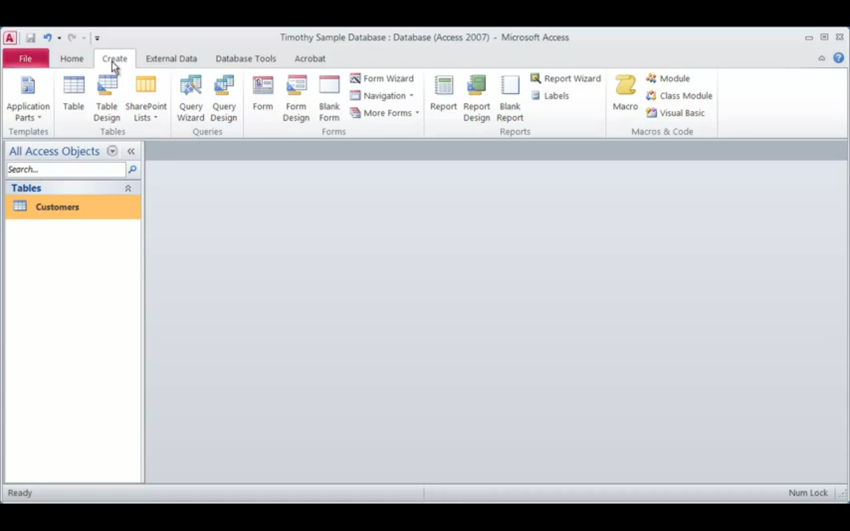

1. Create a new field called “Product ID” of data type “AutoNumber”.
2. From the ”File” Tab Select “Primary Key” to make “Product ID” the primary key for this table.
3. Add the following fields to the table.

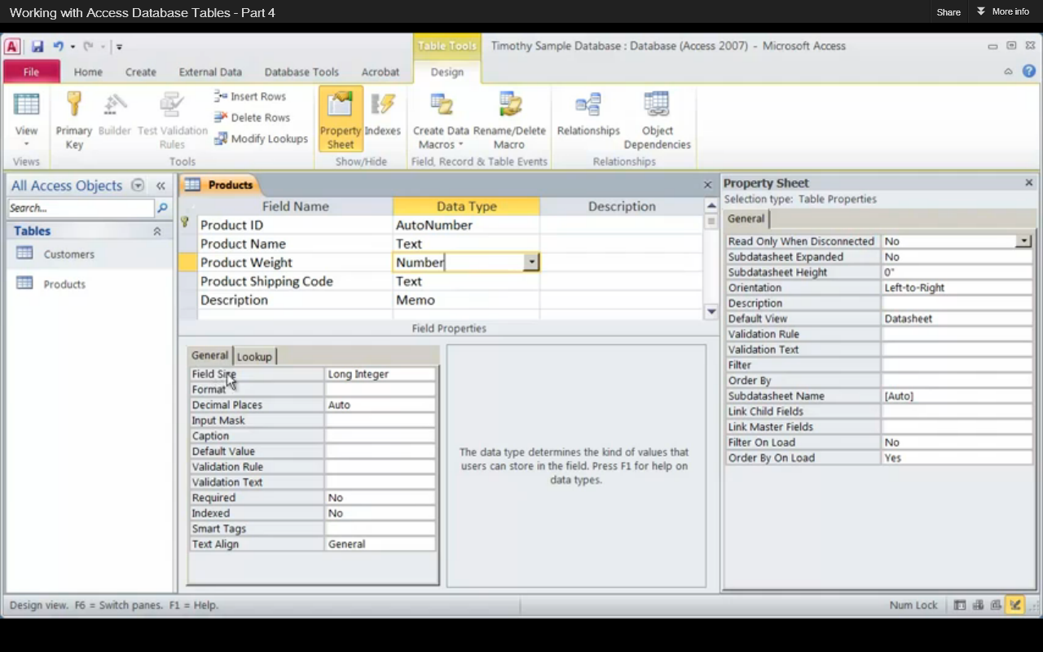

1. Modify the field size for “Product Name” to 55, “Product Shipping Code” to 10 and “Product Weight” to “Long Integer”.
2. Enter the following records in the table “Products”.
3. Save and close the “Products” table.

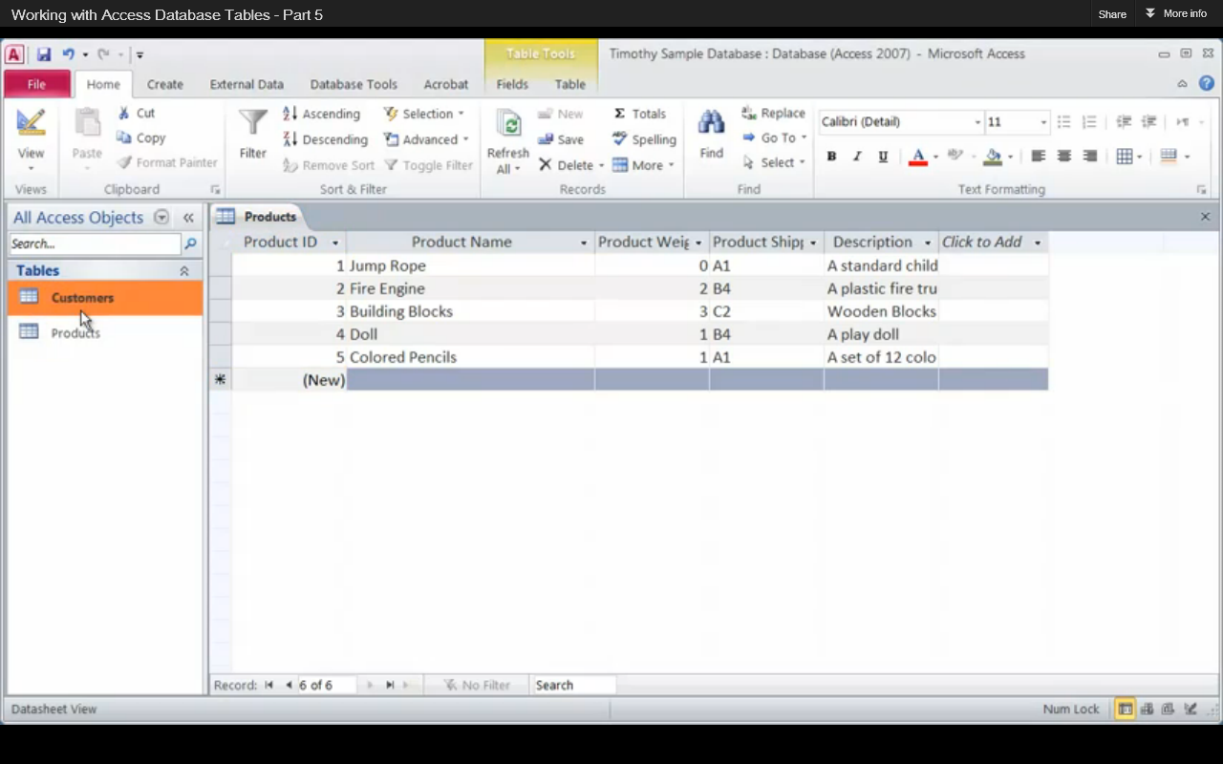

1. Create a new table called “Orders”. Based on the following data, and save the table.

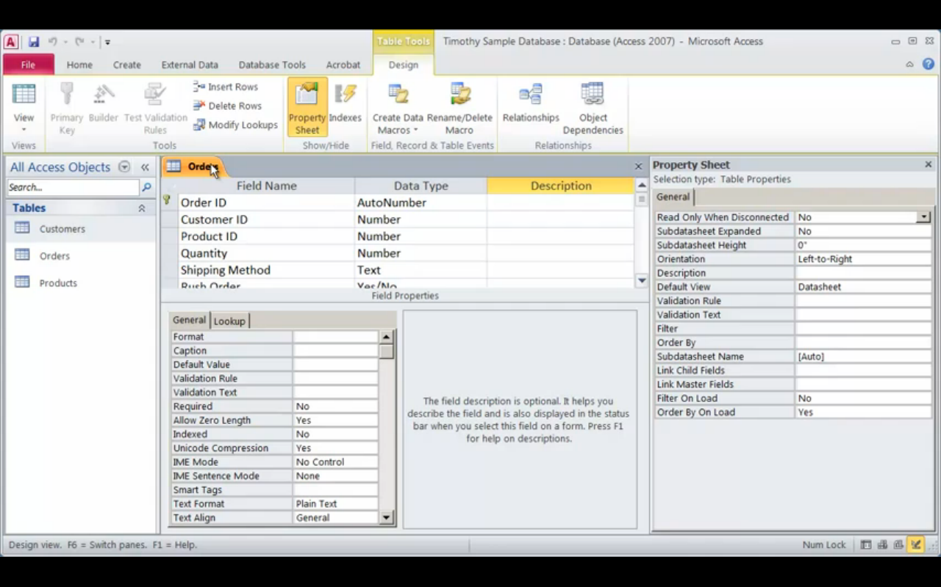

1. Open the “Product “ table and insert a field above “Product Shipping Code” called “Price”. Select “Currency” for the “Data Type”.

**Working with forms.**

**Relationships**

Relationships always go from source to target. Source is where object where the data listed.

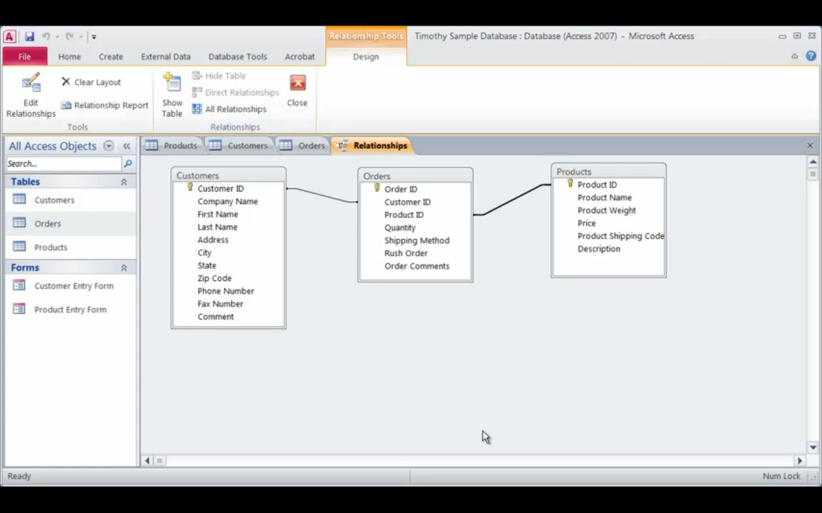

|  |  |
| --- | --- |
| **Data Type** | **Info** |
| Text field | 255 characters |
| Number | Can perform mathematical operation on the data. (+ , x, -, ÷) |
| Memo field | 65 000 characters. |